COLLEGE PREP
SECTION 1.2B - INTRO TO PROBLEM SOLVING

Objectives:
- Solving problems using mathematical models, specifically direct translation, simple interest, mixture, and work problems.

STEPS FOR SOLVING WITH MATHEMATICAL MODELS (Review):
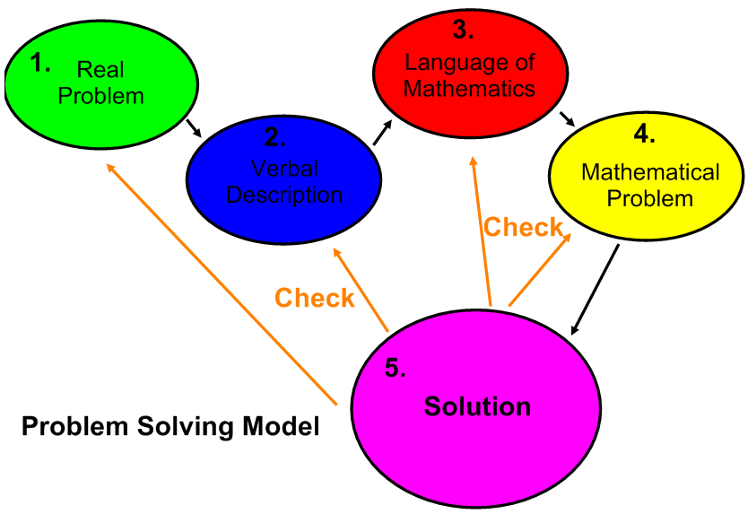

FIVE CATEGORIES OF PROBLEMS:
1. Direct Translation – problems where we must translate from English into mathematics by translating a verbal description.
2. Mixture - problems where two or more quantities are combined in some fashion.
3. Geometry – problems where the unknown quantities are related through geometric formulas such as perimeter or area.
4. Uniform Motion – problems where an object travels at a constant speed.
5. Work Problems – problems where two or more entities join forces to complete a job.

INTEREST RATE PROBLEMS:
Use the $I=Prt$ formula, where $I$= simple interest, $P$=principal, $r$= annual interest rate,
and $t$= time in years. Keep in mind that the interest rate must be written as a decimal, not a percent! Divide the interest rate percentage by 100 to find the decimal equivalent. Also – watch your time! $t$ always describes years.

Example 1: Daniel has a credit card balance of $1600. Each month the credit card company charges 15.5% annual simple interest on outstanding balances. What is the interest that Daniel will be charged on this credit card balance after one month? What is Daniel’s credit card balance after one month?

First: Identify the values for the variables in our formula. We are looking for interest, so $I$ is the unknown. Principal$=P=1600$, Rate $=r=15.5\%=.155$, and time in years $=t=\frac{1}{12}$. Why does $t=\frac{1}{12}$? Because time is always in years, and 1 month is one twelfth of a year.
Second: Plug in the values and solve for $I$. $I=1600\left(.155\right)\left(\frac{1}{12}\right)= \$20.67$
ANSWER: The interest after one month is $\$20.67.$ The total balance equals principal plus interest, so$\$1620.67.$

Example 2: Suppose that you have$1400 in savings. The bank pays 1.5% annual simple interest. What would be the interest paid after 6 months?

$I=Prt=1400\left(.015\right)\left(\frac{6}{12}\right)=\$10.50$
MIXTURE PROBLEMS: problems in which two or more items are combined to form a third item. Keep in mind the following idea when solving mixture problems: Portion from Item A + Portion from Item B = Whole or Total. Sometimes it helps to organize your data into a table.

Example 3: Alicia has $70,000 to invest. She can invest in a certificate of deposit (CD) that pays 8% a year, and the rest will go into corporate bonds paying 12% per year. How much money should be invested in each for her to earn $6300 in interest in a year?

Step 1: Identify. We want to know the total amount of interest gained from each investment, and we want it to add to $6300. So: CD Interest + Bond Interest = Total Interest = $6300.
Step 2: Name the variables. Let’s let $c=amount in CD^{'}s$. Since there is $70,000 total, that means that $70,000-c=amount in bonds$
Step 3/4: Organize what you know in a table and create a model/ solve.

What investment? | Principal amount | Annual % rate | Time in years | Interest ($I=Prt)$
CD’s | $$c$$ | 8% = .08 | 1 | = $.08c$
Bonds | $$70,000-c$$ | 12% = .12 | 1 | = $.12\left(70,000-c\right)$
TOTALS | 70,000 | ? (but not needed) | 1 | = $6300

We know that Interest from CD’S + Interest from Bonds = $6300, so
$.08c+.12 \left(70,000-c\right)=6300$ the model
$.08c+8400-.12c=6300$ combine c’s and subtract 8400 from both sides
$-.04c= -2100$ divide by -.04
$c=52, 500$

Step 5/6: Check and answer. If $52,500 is the amount in CD’s, then $70,000-$52,500 = 17,500 goes into bonds.

Example 4: A store manager wants to mix peanuts and M&M’s to make a trail mix. She wants to create 10 pounds of the mix and sell it for $5.10 per pound. If the price of peanuts is $3 per pound and the price of M&M’s is $6 per pound, how many of each type should she use so that the value of the mixture is the same as the value of the individual items?

Step 1 / 2: Identify and name. Peanuts +M&M’s = total amount of trail mix. Let $p=amount of peanuts$
If there is 10 pounds of trail mix, then $p+M\&M^{'}s=10$, so amount of M&M’s$=10-p$
Step 3 / 4: Organize the data into a table to find the model, then solve.

Ingredients | Price per pound | Number of pounds | Value = Price x pounds
Peanuts | $3.00 | $$p$$ | $$3.00p=3p$$
M&M’s | $6.00 | $$10-p$$ | $$6.00\left(10-p\right)=60-6p$$
TOTALS | $5.10 | 10 | $$5.10\left(10\right)=51$$

Value of peanuts + Value of M&M’s = Total Value
$3p + 60-6p = 51$ Substitute values
$-3p+60=51$ combine like terms (p’s)
$-3p=-9$ subtract 60 from both sides
$p=3$ divide both sides by -3.

Step 5 /6: Answer. Check! Does the answer make sense?
If $p=3$, then we have 3 pounds of peanuts, which means we have 10-3= 7 pounds of M&M’s.

UNIFORM MOTION PROBLEMS:
Use the $d=rt$ formula, where $d=distance, r=average speed or rate, t=time$. Make sure that if your times or distances are in different units of measure you convert everything to the same units of measure.

Example 5: Tanya is a long-distance runner who runs at an average speed of 8 miles per hour. Two hours after Tanya leaves, her friend Sophie gets in her car and follows the same route. If Sophie’s average speed is 40 mph, how long will it be before she catches up to Tanya?

Step 1 /2: Identify & translate. This problem is talking about speed/motion, so it’s a uniform motion problem, which means we need to use the d=rt formula. Since the question is “How long…”, that means that our unknown variable is time ($t$). Let’s say Sophie’s time = $t$, which means Tanya’s time = $t+2$ (since she ran 2 hours longer than Sophie drove).
Step 3 /4: Translate and solve.

Who? | Rate (mph) | Time (in hours) | Distance (d=rt)
Tanya | 8 | $$t+2$$ | $$d=8\left(t+2\right)=8t+16$$
Sophie | 40 | $$t$$ | $$d=40t$$

Since we know that Sophie catches up to Tanya after driving the same route, that means they’ve gone the same distance: Tanya’s distance (d) = Sophie’s distance(d)
$8t+16 = 40t$ Substitute in values.
$16=32t$ Subtract 8t from both sides.
$t=$1/2 Divide both sides by 32.
Step 5 /6: Answer and check for reasonableness. If Sophie drove at 40 mph for ½ hour, then she drove 20 miles. If Tanya ran 8 mph for 2 ½ hours, she ran 20 miles.
ANSWER: ½ hour

Homework: Pg. 76: # 30, 37, 40, 42, 43, 49-51 all, 53, 57, 59, 61, 63, 65, 68

