**Extra Credit 50 - 53**

**Extra #50**

**Change each degree measure to radian measure**

**1.** 6 $°$**2.** 870 $°$**3. $-165°$**

**Change each radian measure to degree measure**

**4. $\frac{-7π}{9}$** **5. $2\frac{3}{5} π$**  **6. $\frac{13π}{30}$**

**Extra #51**

**Evaluate **

**1. $\cos{\frac{5π}{4}}$ 2. $\tan{\frac{11π}{6}}$ 3. $\tan{300°}$**   **4. $\sin{210°}$**

**Find $θ$ in radians (you may have more than 1 answer)**

**5. $\tan{θ}=-1$**

**Find $θ$ in degrees (you may have more than 1 answer)**

**6. $\cos{θ}= \frac{\sqrt{3}}{2}$**

**Extra #52**

**Use for 1-3 Use for 4-6**

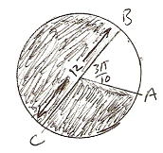 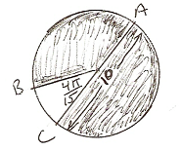

**1.** Find the arc length $\hat{AB}$ **2.** Find the arc length $\hat{BCA}$ **3.** Find the shaded area

**4.** Find the arc length $\hat{CB}$**5**. Find the arc length $\hat{BCA}$**6**. Find the shaded area

**Extra #53**

**State the amplitude and period of each function, then draw the graph. You must label 4 angles on the x-axis.**

**1.** y = $2 \sin{(\frac{3}{4}x)}$ **2.** y = $\frac{1}{2} \cos{(\frac{6}{7}x)}$ **3.** y = 5 $\sin{(\frac{3π}{5}x)}$